

**COMSATS UNIVERSITY ISLAMABAD**



**DEPARTMENT OF COMPUTER SCIENCE**



# Pharmacy Record Management System

***By***

**Muhammad Shahbaz CIIT/FA19-BSE-003/VHR**

**Muhammad Awis Qurne CIIT/FA19-BSE-005/VHR**

***Supervisor***

**Mr. Nashit Ali**

***Bachelor of Science in Software Engineering (2019-2023)***

# DECLARATION

We hereby declare that this software, neither whole nor as a part has been copied out from any source. It is further declared that we have developed this software and accompanied report entirely on the basis of our personal efforts. If any part of this project is proved to be copied out from any source or found to be reproduction of some other. We will stand by the consequences. No Portion of the work presented has been submitted of any application for any other degree or qualification of this or any other university or institute of learning.

Muhammad Shahbaz Muhammad Awis Qurne

-------------------------- -------------------------------

**CERTIFICATE OF APPROVAL**

It is to certify that the final year project of BS (SE) “Project title” was developed by **Muhammad Shahbaz (CIIT/FA19-BSE-003)** and **Muhammad Awis Qurne (CIIT/FA19-BSE-005)** under the supervision of “Sir Nashit Ali” and that in her opinion; it is fully adequate, in scope and quality for the degree of Bachelors of Science in Computer Sciences.

---------------------------------------

**Supervisor**

---------------------------------------

**External Examiner**

---------------------------------------

# ACKNOWLEDGEMENT

All praise is to Almighty Allah who bestowed upon us a minute portion of His boundless knowledge by virtue of which we were able to accomplish this challenging task. We are greatly indebted to our project supervisor “Mr. Nashit Ali”. Without his personal supervision, advice and valuable guidance, completion of this project would have been doubtful. We are deeply indebted to them for their encouragement and continual help during this work. And we are also thankful to our parents and family who have been a constant source of encouragement for us and brought us the values of honesty & hard work.

Muhammad Shahbaz Muhammad Awis Qune

--------------------------- -----------------------------

# 

# ABBREVIATIONS

|  |  |
| --- | --- |
| **SRS** | Software Requirement Specification |
| **PC** | Personal Computer |
|  |  |
|  |  |
|  |  |

**ABSTRACT**

The Pharmacy Record Management System (PRMS) is a desktop application designed to effectively manage and organize pharmacy records in a streamlined and automated manner. This application serves as a centralized platform for storing, retrieving, and updating crucial information related to medication dispensing, patient profiles, prescriptions, inventory management, and billing within a pharmacy setting. One of the key functionalities of the PRMS is to ensure accuracy, safety, and compliance with legal and regulatory requirements. Additionally, the system supports electronic prescribing and transmission of prescriptions to pharmacies, reducing reliance on paper-based processes and enhancing efficiency. The PRMS desktop application encompasses inventory management capabilities, enabling real-time tracking of medication stock levels, expiration dates, and automatic reordering.

The Pharmacy Record Management System (PRMS) desktop application provides an efficient and user-friendly solution for managing pharmacy records. It improves accuracy, efficiency, and patient safety, while also reducing paperwork and administrative burdens for pharmacy staff. By centralizing and automating various tasks, the PRMS enhances the overall workflow and effectiveness of pharmacy operations.

**TABLE OF CONTENTS**

1. INTRODUCTION 9

1.1 System Introduction 9

1.2 Background of the System 9

1.3 Objectives of the System 10

1.4 Significance of the System 10

2. REQUIREMENT SPECIFICATIONS 11

2.1 Product Scope 11

2.2 Product Description 11

2.2.2 Product Functionality 11

2.2.3 Users and Characteristics 12

2.2.4 Operating Environment 12

2.3 Specific Requirements 13

2.3.1 Functional Requirements 13

2.3.2 Behaviour Requirements 14

2.3.3 External Interface Requirements 15

2.4 Non-Functional Requirements 25

2.4.1 Performance Requirements 25

2.4.2 Safety and Secruity Requirements 25

3. DESIGN DESCRIPTION 26

3.1 Introduction 26

3.2 Composite Viewpoint 27

3.3 Logical Viewpoint 28

3.4 Interaction Viewpoint 29

3.5 State Dynamics Viewpoint 33

3.6 Algorithmic Viewpoint 34

4 DEVELOPMENT AND TOOLS 37

4.1 Introduction 37

4.2 Development plan 37

4.3 Development Tools 39

4.4 Conclusion and Future Work Extensions 40

5. QUALITY ASSURANCE 40

5.1 Introduction 40

5.2 Traceability Matrix 40

5.3 Test Plan 42

6. USER MANUAL 45

6.1 Introduction 45

6.2 Hardware Software Requirements for The System 46

6.3 User Manual 46

**LIST OF FIGURES**

Figure 1: Use Case Diagram 14

Figure 2: Login Screen 15

Figure 3:Dashborad 16

Figure 4:Place Order 17

Figure 5:Product Details 18

Figure 6: Customer Details Screen 19

Figure 7: Company Details Screen 20

Figure 8: Loan Details Screen 21

Figure 9: Stock Details Screen 22

Figure10: Logout Screen 23

Figure 11: Deployment Diagram 27

Figure 12: Class Diagram 28

Figure 13: Sequence Diagram of Login To Retail Arbitrage 29

Figure 14: Sequence Diagram of Customer Activities 30

Figure 15: Sequence Diagram of Company Activities 31

Figure 16: Sequence Diagram of Product Activities 32

Figure 17: State Machine Diagram 33

Figure 16: Gant Chart 38

**LIST OF TABLES**

Table 1:Software Interface 25

Table 2: Development Tools 39

Table 3: User Traceability 41

Table 4:Admin: Traceability 41

Table 5:Test Case Login 42

Table 6: Search Products 42

Table 7: Manage Profile 44

Table 8: Add Cart 44

Table 8: Order Product 45

# 1. INTRODUCTION

In this chapter the user will know about the system introduction that what this Pharmacy Record Management system (Desktop Application) is all about and the background of the system that what competitors are there in the market having the similar software and why our App is different from them. Also, the user will come to know about the objectives of the Desktop App and how significant this Desktop app is.

## 1.1 System Introduction

The Pharmacy record management system is the system used for medicine stock inventory in the pharmacy. This system enables the manager of the pharmacy to record and manage all activities of the pharmacy. The Pharmacy Record Management System is a comprehensive software solution designed to streamline and automate the management of records within a pharmacy setting. It aims to enhance efficiency, accuracy, and security in handling various pharmacy-related records such as prescriptions, medication inventory and billing.

It is accessible either to administrator. Only administration can add data into the database. This system also enables the workforce of the pharmacy to offer their services in a manner which is more efficient and systematic which also improve of the pharmacy. The pharmacy record management software enables to maintain the details of purchase stock by the pharmacy and the details of the selling stock by customer wise. The pharmacy record management software enables to maintain the details of purchase stock by the pharmacy and the details of the selling stock by customer wise.

## 1.2 Background of the System

The current manual system has a lot of paper work to do. To maintain the records of sale and services manually, is a time-consuming task. With the increase in information, it will become a huge task to maintain the database. Requires large quantities of the file’s cabinets, which are huge and requires a lot of space in the office, which can be used for storing the previous details. The retrieval of previous records will be tiring. Lack of security for the records of Pharmacy Management System. If anyone wants to check the previous records there will be inadequate information available.

The Pharmacy Management system is computerized management system designed for any Pharmacy to replace the existing manual system. The new system will maintain the data of Customer, Salesman and Admin. These services are to be provided to be in efficient, cost-effective manner, with the goal of reducing the time and currently required for such tasks. It is simple, fast and user-friendly. It reduces the paper work. This project is GUI based that will help in storing, updating and retrieving the information through various user-friendly menu-drives modules. The system's reporting and analytics capabilities enable pharmacies to gain insights into medication trends, optimize inventory management, and identify cost-saving opportunities.

## 1.3 Objectives of the System

The main objective of this project is to develop a Desktop Application that will simplify

* It will help to look for the customer details and manage it.
* It also maintains the medicine information such as the available in pharmacy.
* It can also provide the admin to store the report in the database and make it available to the customer.
* We give a admin name and password of Desktop Application to maintain the records.
* Capture, store and maintain customer, supplier and product records.
* To reduce paper work and cost associated.
* The system prioritizes data security and confidentiality by implementing stringent security measures, including user authentication, data encryption, and access controls.

## 1.4 Significance of the System

The system automates manual processes, reduces paperwork, and eliminates redundant tasks, leading to improved operational efficiency in pharmacies. It saves time, enhances productivity. Pharmacy Management System is a Desktop application. It is developed to optimize and digitize all the processes within the pharmacy. But keeping in view that information will only be handled by a trained person. It will help to improve customer services, reduce the process costs. It will streamline the admin, medicine records, bills, customer, etc. A system requirement is done by the system such as store the necessary information of drugs, prepare bill for medicine, give weekly reports easily searching of medicine. The system can be scaled to accommodate the growing needs of pharmacies and can be adapted to suit different types of pharmacy settings, including retail pharmacies, hospital pharmacies, and specialty pharmacies. It provides flexibility in customization and integration with other healthcare systems.

# 2. REQUIREMENT SPECIFICATIONS

In this chapter the user will know about the product scope that what are the boundaries of the Desktop app (e.g., the dos and don’ts) also the user will come to know about the perspective of the app, functionality of the Desktop app, what are the users and characteristics of them and the environment in which the Desktop app will operate.

## 2.1 Product Scope

The system will be used as the Desktop application that serves the Pharmacy System. The intention of the system is to increase the number of customers that can be managed efficiently. Bills are generated by recording price for each medicine price provided by Admin. The Pharmacy management is file-based management of the system has to put much effort on securing the files before that system. They can be easily damaged by fire, insects, and natural disasters. Also, could be misplaced by losing data and information. Now by using that system they store record in database and create backup.

## 

## 2.2 Product Description

**2.2.1 Product Perspective**

This Pharmacy Management system is self-contained system that manages the day-to-day activities of the pharmacy. Due to inappropriate details pharmacy management center faces a lot of difficulties in facing the accessing the past data as well as management of fresh data. This well-developed Desktop application will overcome the disadvantages of manual system by improving the reliability, efficiency and performance. The creation of database for the admin’, customer’, medicine and other employees’ details etc. will make easy to edit, retrieval, search and any amendments in information. The access limitations of every user will enhance the security of the system. The system also includes a user interface that allows pharmacy staff to interact with the software and perform various tasks such as entering and retrieving patient information, managing prescriptions, and monitoring inventory levels. It will improve the efficiency of pharmacy operations.

### 2.2.2 Product Functionality

Modules of Pharmacy Record Management System Desktop App are:

* Admin can access to control the system and maintain it.
* Admin can generate receipt of medicine to customer.
* Admin can update their record.
* Administer user accounts, roles, and permissions to ensure secure access and control over the system.
* Track and manage the inventory of medications, including stock levels, expiration dates, and supplier information.
* Customer can do payment.
* Modification in schedule by Admin.
* Admin’s access to Customer record.
* Admin verify payment and generate bill.
* Admin can view monthly/yearly records.

### 2.2.3 Users and Characteristics

This Desktop application has one module _the administration modules. This system will only help the administrations to preview the monthly and yearly data but it will also allow them to edit, add or update records. The administration will be able to manage and update the medicine’ information.

**2.2.4 Operating Environment**

**Operating System:** Window 10 Or Higher or macOS (for Mac computers)

**RAM:** 4 GB RAM or Higher

**Memory (Storage):** 200 (Gaga Byte) of Device Storage.

**Chipset:** 1.6GHz or faster-processor

### Hardware Requirements

* + 1.6GHz or faster-processor
  + 4GB RAM or higher
  + 256 GB hard disk space
  + 1280 x 800 or higher screen resolution

**2.2.4.2 Software Requirements**

* Windows XP, Windows 10, or above operating system
* Microsoft SQL Server, Visual Studio 2019 or above
* Visual Studio 2019 0r above

**2.2.4.3 Minimum Plate-form Requirements**

* Intel core i3 or faster-processor
* 2GB RAM
* 128 GB hard disk space
* 1280 x 800 or higher screen resolution

## 2.3 Specific Requirements

### 2.3.1 Functional Requirements

There will be following Requirements of this application:

* Admin Login
* User friendly interfaces
* Interfaces validation check for entry, update, delete, search etc.
* Medicine(s) record entry, update, delete
* Track all information of medicine(s), inventory, pharmacy
* Shows information and descriptions of pharmacy, stocks
* Bill calculation.
* Record updating in case medicine(s) sold, returned
* Total Cost of all medicines
* Calculate total profit
* Deduct amount from total sales if the customer returns medicine(s)
* Updating quantities of medicine(s) in case of populating pharmacy with medicines.
* Report generation
* Show the list of short items
* Show the brand name with medicine name

### 

**2.3.2 Behavior Requirements**

The use case diagram of Pharmacy Record Management System Desktop App:

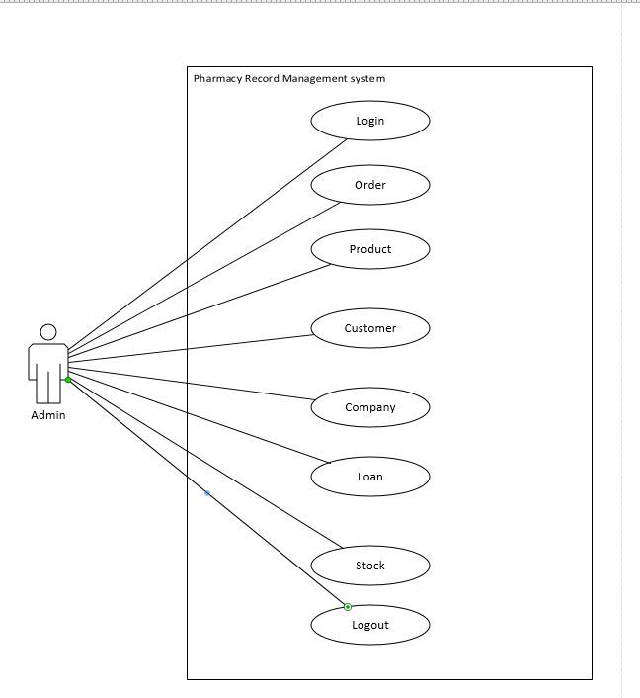

Figure : Use Case Diagram

**2.3.3 External Interface Requirements**

2.3.3.1 User Interfaces

The system is designed in such a way that the User can add data, edit data and delete data about the medicine and manufacture company. And we also use a small printer to print the receipt of customer medicine bill.

* + - * 1. Login Screen

The system is designed in such a way that the User first add their user’s name or password to access this Software to Further perform operation. Otherwise, they did not access this system.

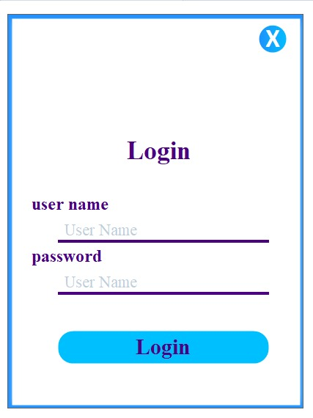

Figure : Login Screen

**2.3.3.1.2 Dashboard**

When The User Login Successfully in this desktop app. After Load main Dashboard screen where the access different type of option to perform it. In Dashboard the check Customer, check their Orders, check their Sales, Total Cash and Loan Details.

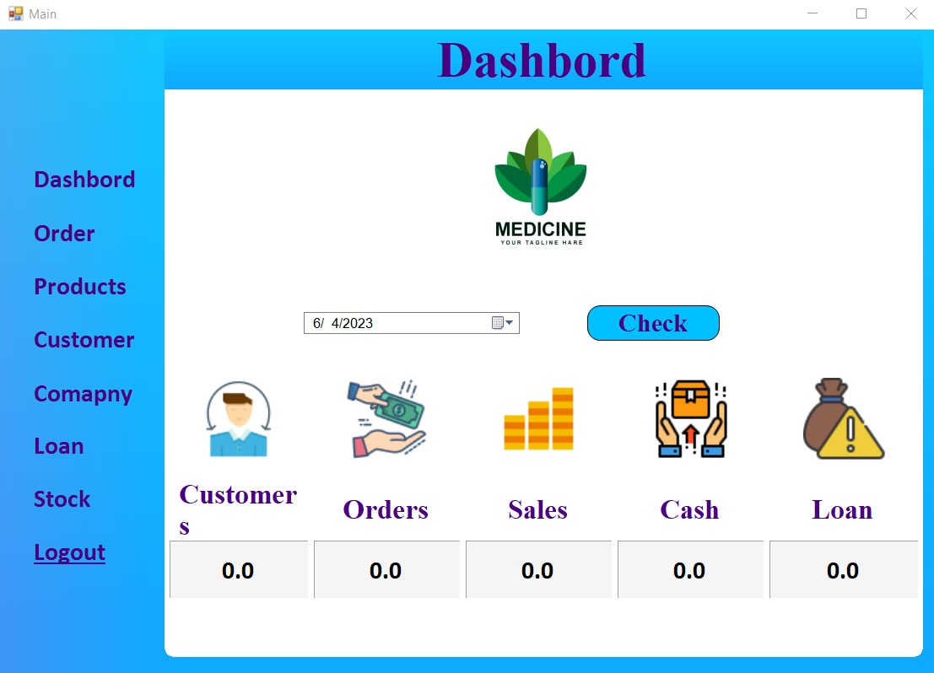

*Figure 3: Dashboard*

* + - * 1. **Place Order**

In Place order is a process where users can select products, specify quantities, and provide necessary details for order fulfilment their requirements as them need to order.

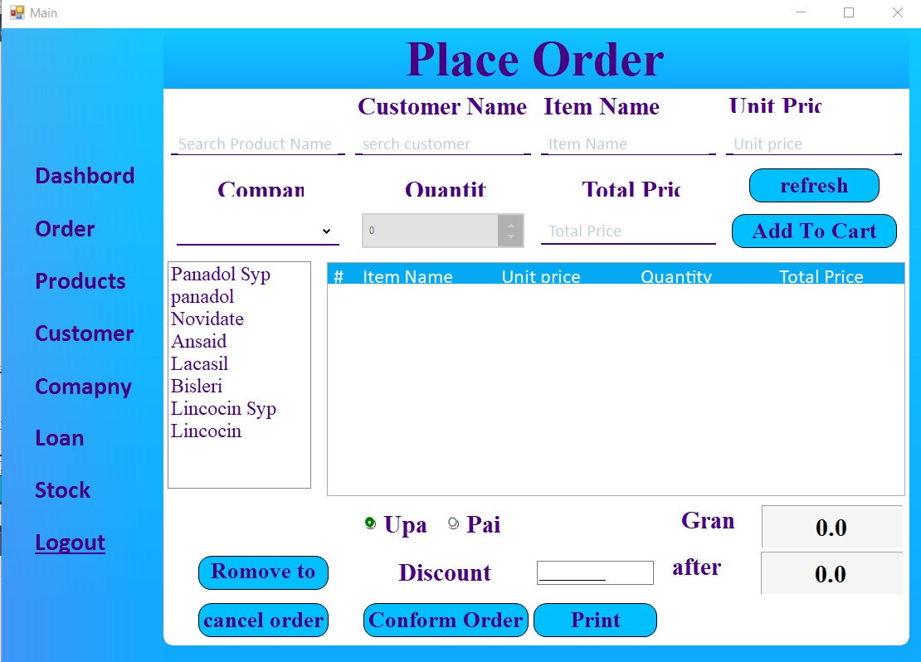

*Figure 4: Place Order Screen*

**2.3.3.1.3 Product Details**

Pharmacy Record Management System (PRMS), the "Items Details" section provides comprehensive information about the medications and products available in the pharmacy inventory.

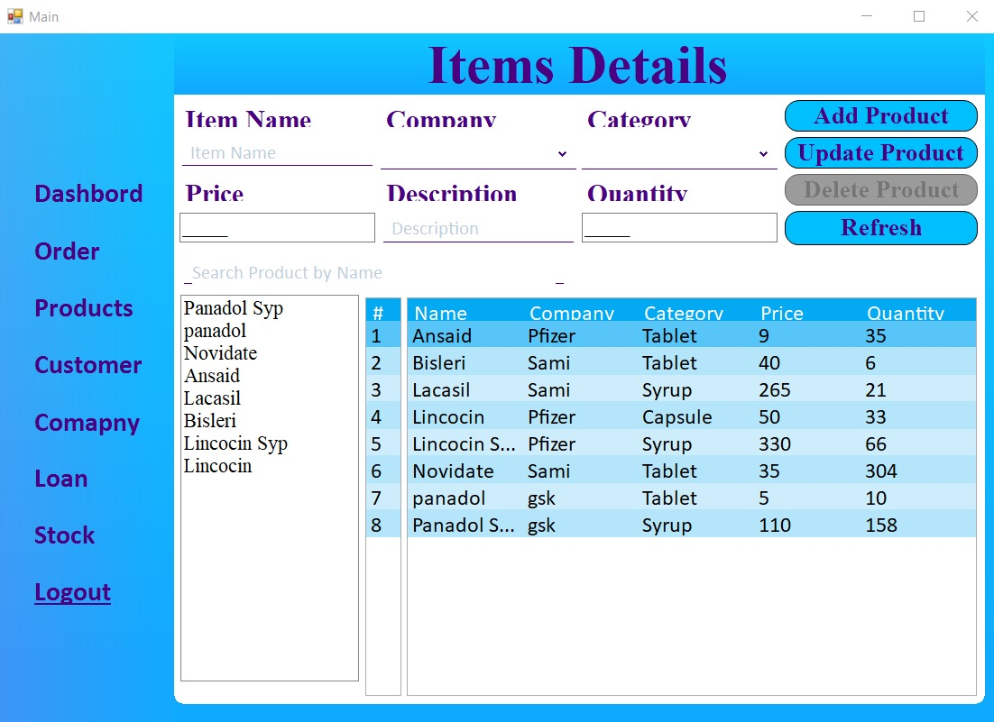

*Figure 5: Product Details Scree*

### 2.3.3.1.4 Customer Details Screen

The "Customer Details" screen in a Pharmacy Record Management System (PRMS) desktop application is designed to store and manage relevant information about pharmacy customers. It provides a comprehensive view of customer details, allowing pharmacists and administrators to effectively manage customer-related activities.

### 

*Figure 6: Customer Details Screen*

**2.3.3.1.5 Company Details**

### The "Company Details" screen in a Pharmacy Record Management System (PRMS) desktop application provides a comprehensive view of the pharmacy or company details. It allows users to manage and maintain information related to the pharmacy's business operations. Also the can add information about medicine company update and delete their data.

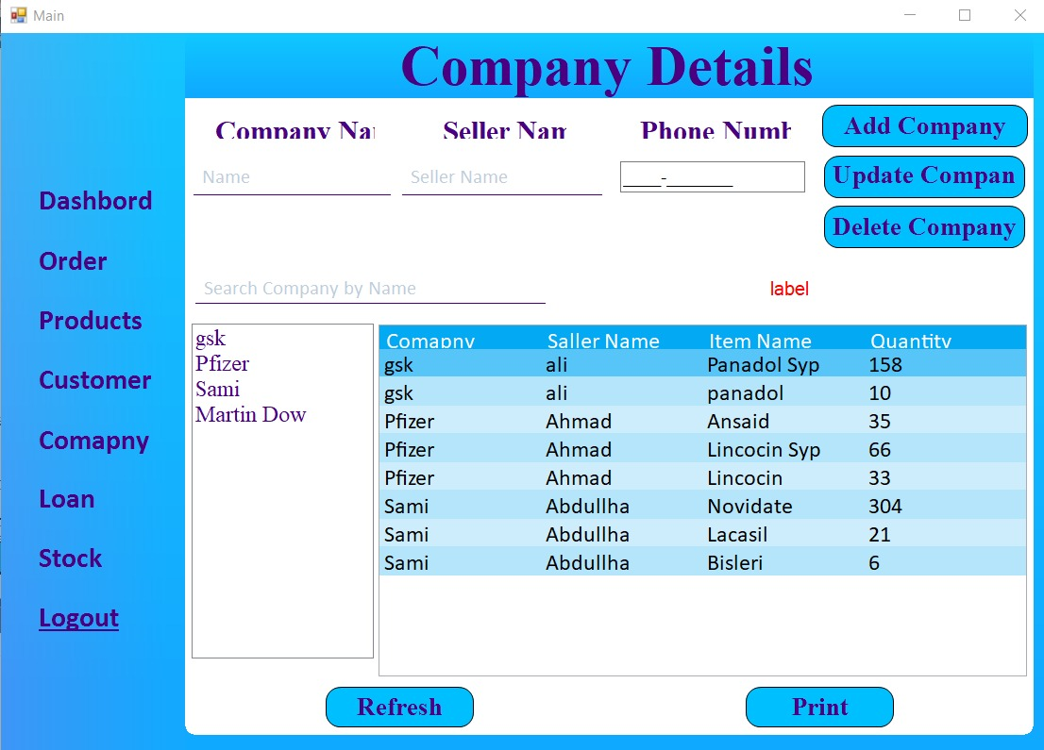

*Figure 7: Company Screen*

### 2.3.3.1.6 Loan Details Screen

### 

### In a Pharmacy Record Management System (PRMS) desktop application, the "Loan Details" screen provides information and management capabilities related to loans or financial transactions. It allows users to track and manage loans provided to customers or any financial obligations within the pharmacy system.

### 

### 

*Figure 8: Order Detail and Profile Screen*

### 2.3.3.1.7 Stock Details Screen

In a Pharmacy Record Management System (PRMS) desktop application, the "Stock Details" screen provides comprehensive information and management capabilities related to the pharmacy's inventory. It allows users to view, track, and manage the stock of medications and products.

### 

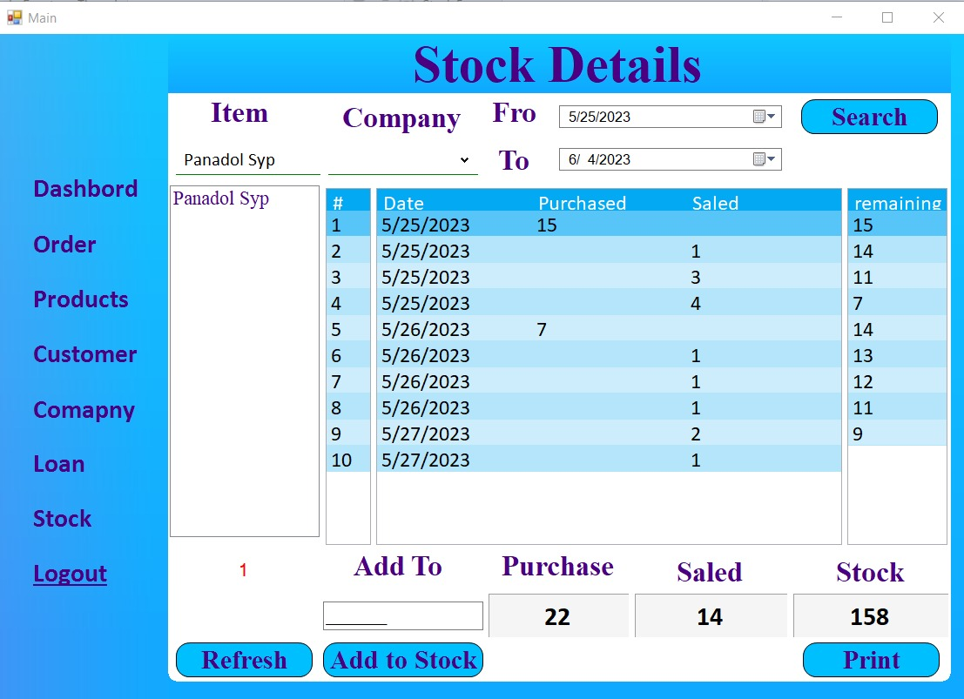

*Figure 9: Message and Profile edit Screen*

**2.3.3.1.8 Logout Screen**

The "Logout Screen" in a Pharmacy Record Management System (PRMS) desktop application provides a secure and controlled way for users to log out of the system. It ensures that user sessions are terminated properly, maintaining data privacy and system security.

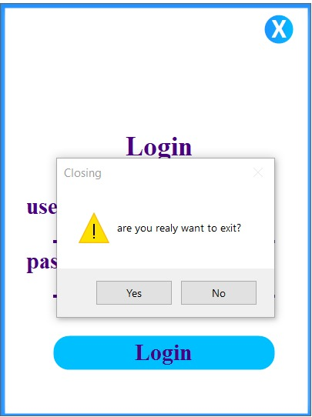

*Figure 9: Logout Screen*

* 1. **Hardware Interfaces**

### 3.2.1 Client Side

|  |  |  |  |
| --- | --- | --- | --- |
| **Application** | **Processor** | **RAM** | **Hard Disk** |
| Laptop/Desktop | At Least Dual Core i3  1.6GHz | 1GB | 200GB |

*Table 1: Client Side*

### Server Side

|  |  |  |  |
| --- | --- | --- | --- |
| **Application** | **Processor** | **RAM** | **Hard Disk** |
| Laptop/Desktop | At least Core i5 At  2.70GHz | 4GB | 256GB |
| Mac/Ios | At least Core i3 At  2.70GHz | 4GB | 1TB |

*Table 2: Server Side*

**Note:** The above-mentioned hardware interfaces are of minimum requirements.

**2.3.3.2 Software Interfaces**

The software interfaces of Pharmacy Record Management System Desktop App are Follows:

|  |  |  |
| --- | --- | --- |
| **Tool & Technologies** | **Version** | **Reason** |
|  |  |  |
| Windows | 10 or Higher | Operating System used to develop “Pharmacy Record Management System App” |
| C# | 4.7 | Framework to develop “Pharmacy Record Management System App” |
| .Net Farmwork | 4.7 | Programming language used in this Framework |
| Microsoft SQL Server Management Studio | Database SQL 2017 | Used as database management system |
| Visual Studio | 16.11 (User Setup) | Used to write .Net Code |
| Git | 2.38.0. windows.1 | Used to tracking change in the source code and pushing my repositories to my git-hub account |
| Adobe XD | 54.1.12 | Used to create the GUI of “Of Pharmacy Record Management System” |

Table :Software Interface

## 

### Communications Interfaces

The database will communicate this system is designed in a way that it follows some protocols and avoids failures. The communication of the system and admin can be done through the computer.

## 2.4 Non-Functional Requirements

### Performance Requirements

### Response Time: The system provides acknowledgment in just one and half second when the admin is searching the information about medicine.

* **Capacity:** The system needs to support at least one person at a time.
* **User-Interfaces:** The user interfaces knowledges within five seconds.

**2.4.2 Safety and Security Requirements**

* **Administration:** The administration can view as well as alter any information in the system.
* **Login ID**: Any admin who wants to use the system needs to hold on Login ID and password.

#### 2.4.2.1 Matin Ability

It is necessary to eliminate errors in the system during its working life and to true the system to any variations in its working environments.it has been seen that there are always some errors found in the system that has noted and corrected.

* + - **Back-up**: The system is efficient for data backup.
    - **Errors**: The system will track every mistake as well as keep log of it.

#### 2.4.2.2 Scalability

Software that is scalable has the ability to handle a wide variety of system configuration sizes. The nonfunctional requirements should specify the ways in which the system may be expected to scale up (by increasing hardware capacity, adding machines, etc.).

#### 2.4.2.3 Availability

The system is available for all the time but the access level is controlled for each Admin.

#### 2.4.2.4 Useability

Ease-of-use requirements address the factors that constitute the capacity of the software to be understood, learned, and used by its intended users.

**2.4.2.5 Efficiency**

Specifies how well the software utilizes scarce resources: CPU cycles, disk space, memory, bandwidth, etc.

# 3. DESIGN DESCRIPTION

## 3.1 Introduction

In this chapter the user will come to know the diagrammatic view point of the Desktop App including composite view point in which the deployment diagram will be presented to the user and logical view point in which class diagram will be presented to user and sequence and state machine diagram will be presented to user for interaction and state dynamics view point respectively.

## 3.2 Composite Viewpoint

The deployment diagram of Pharmacy Record Management System Desktop App:

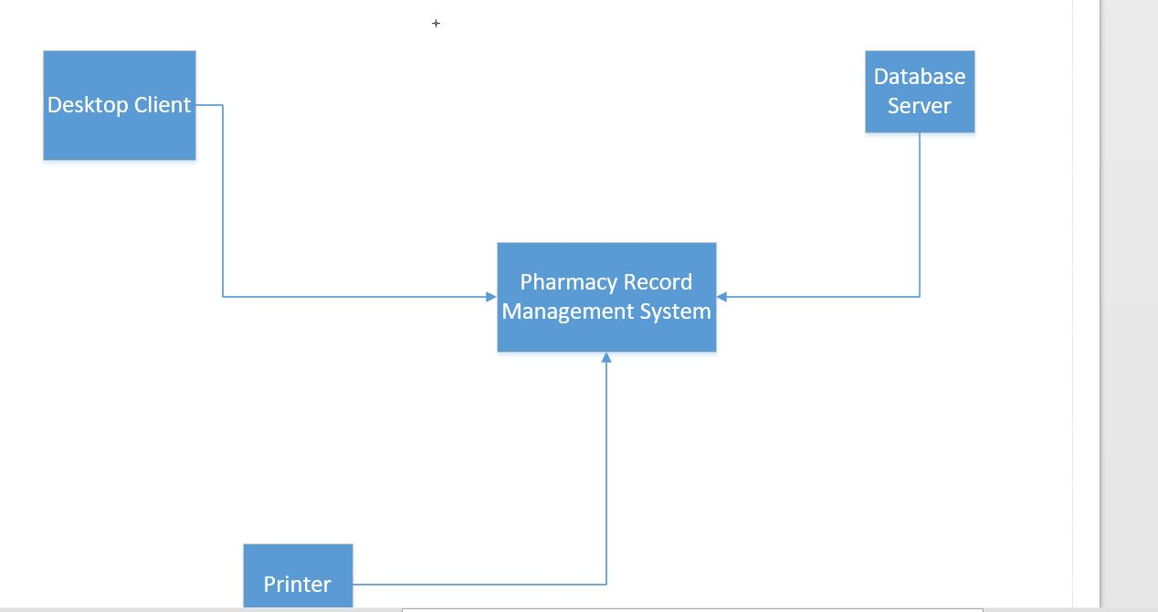

Figure 10: Deployment Diagram

## 3.3.3 Logical Viewpoint

The class diagram of Pharmacy Record Management System Desktop App:

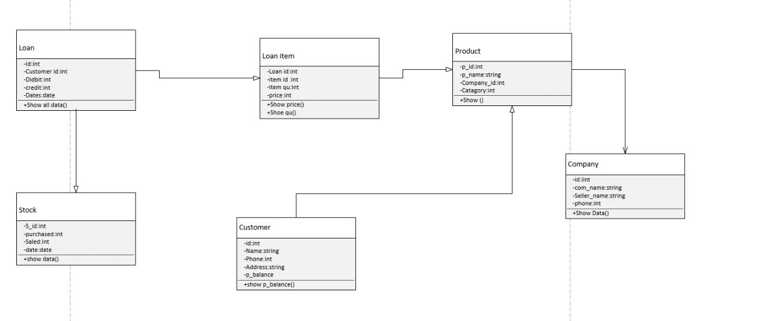

Figure 11: Class Diagram

## 

## 3.3.4 Interaction Viewpoint

The sequence diagram of Login to Pharmacy Record Management System Desktop App:

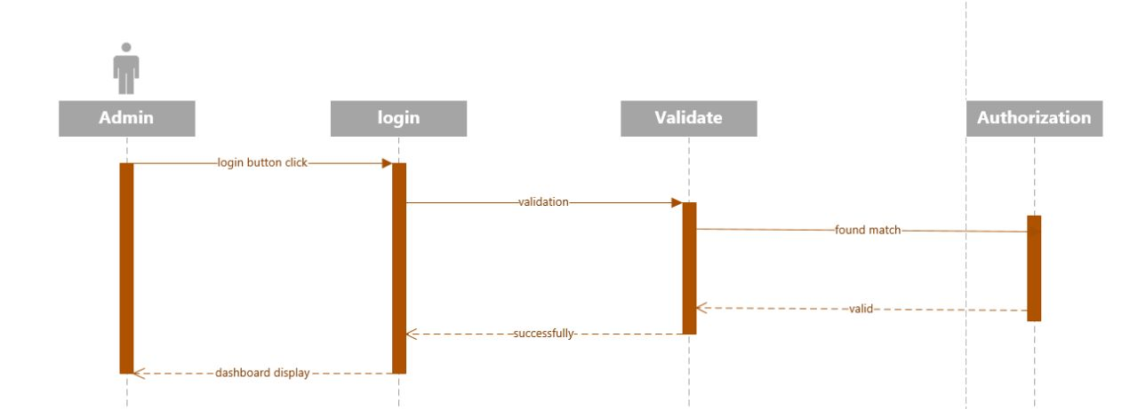

Figure 12: Sequence Diagram of Login to Pharmacy Record Management System Desktop App

**The sequence diagram of Customer Activities:**

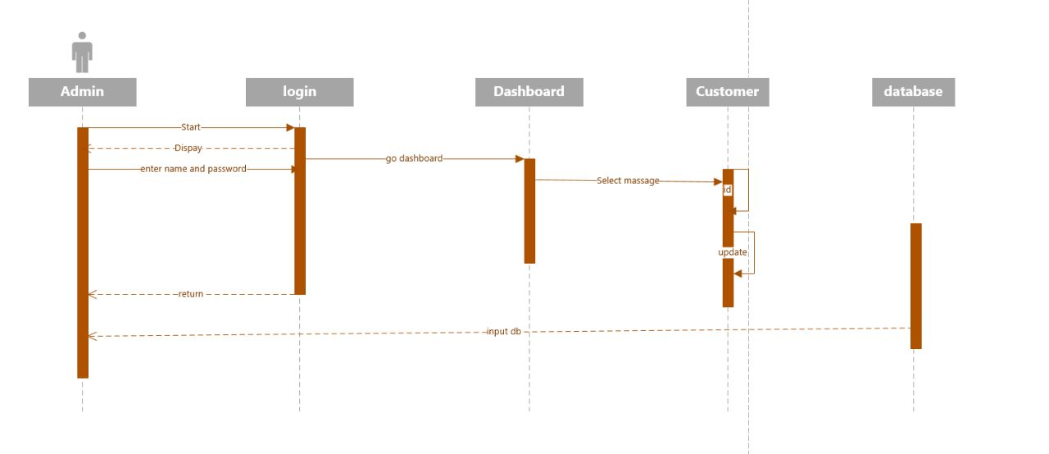

*Figure 13: Sequence Diagram of Customer Activities to Pharmacy Record management System app*

**The sequence diagram of Company**

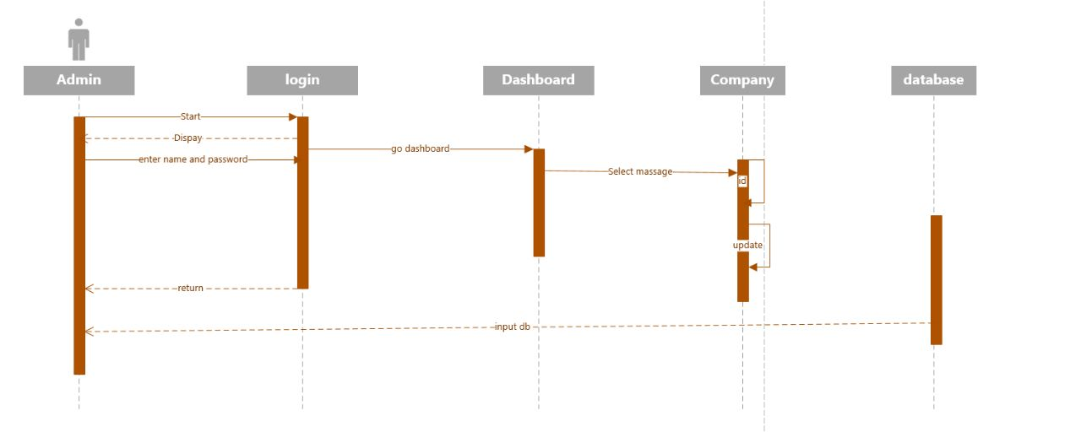

*Figure 14: Sequence Diagram of Company Activities*

**The sequence diagram of Product:**

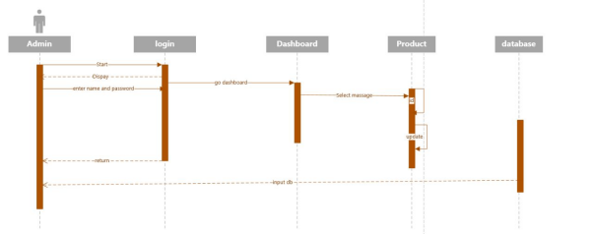

*Figure 16: Sequence Diagram of Product module*

## 3.5 State Dynamics Viewpoint

The sate machine diagram of Pharmacy Record Management System Desktop App:

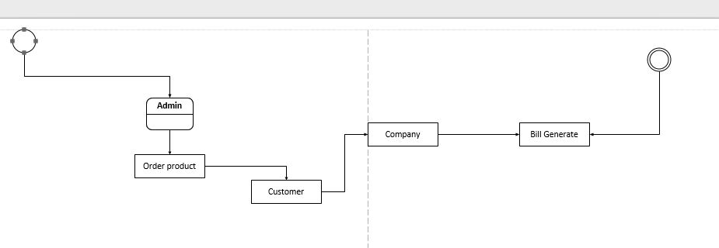

Figure 15: State Machine Diagram

## 

## 3.6 Algorithmic Viewpoint

**Login Page:**

// define variables to store the username and password

String username

String password

Display "Enter your username:"

Read username

Display "Enter your password:"

Read password

If username is valid and password is valid then

Display "Login successful!"

Else

Display "Invalid username or password. Please try again."

**Order Page:**

// Initialize variables

String productName

String customerName

Decimal price

String companyName

Int quantity

Bool isPaid

// user to enter product details

Display "Enter product name:"

Read productName

Display "Enter customer name:"

Read customerName

Display "Enter price of product:"

Read price

Display "Enter company name:"

Read companyName

Display "Enter quantity:"

Read quantity

// create an order object or structure to store the order details

Order order

order.ProductName = productName

order.CustomerName = customerName

order.Price = price

order.CompanyName = companyName

order.Quantity = quantity

// add the order to the cart or order list

Cart. Add (order)

// Prompt user to select payment option

Display "Select payment option (Paid/Unpaid):"

Read paymentOption

If paymentOption is "Paid" then

isPaid = true

Else

isPaid = false

// Confirm the order

Display "Order confirmation:"

Display "Product Name: " + order.ProductName

Display "Customer Name: " + order.CustomerName

Display "Price: " + order.Price

Display "Company Name: " + order.CompanyName

Display "Quantity: " + order.Quantity

Display "Payment Option: " + paymentOption

// Perform any additional actions such as saving the order to a database or generating a receipt

**Company Page:**

// Define variables and data structures

string companyName

string sellerName

string sellerPhoneNumber

// Display Company screen menu

Display "Company Screen"

Display "1. Add Company"

Display "2. Update Company"

Display "3. Delete Company"

// Prompt user for choice

Display "Enter your choice:"

Read choice

// Process user choice

switch (choice)

case 1:

// Add Company

Display "Enter company name:"

Read companyName

Display "Enter seller name:"

Read sellerName

Display "Enter seller phone number:"

Read sellerPhoneNumber

// Add the company to the database or data structure

AddCompany(companyName, sellerName, sellerPhoneNumber)

Display "Company added successfully."

break

case 2:

// Update Company

Display "Enter company name to update:"

Read companyName

// Check if the company exists in the database or data structure

if (IsCompanyExists(companyName))

{

Display "Enter new seller name:"

Read sellerName

Display "Enter new seller phone number:"

Read sellerPhoneNumber

// Update the company details in the database or data structure

UpdateCompany(companyName, sellerName, sellerPhoneNumber)

Display "Company updated successfully."

}

else

{

Display "Company not found."

}

break

case 3:

// Delete Company

Display "Enter company name to delete:"

Read companyName

// Check if the company exists in the database or data structure

if (IsCompanyExists(companyName))

{

// Delete the company from the database or data structure

DeleteCompany(companyName)

Display "Company deleted successfully."

}

else

{

Display "Company not found."

}

break

case 4:

// Exit the Company screen

Display "Exiting Company Screen..."

break

default:

Display "Invalid choice. Please try again."

break

// Continue displaying the Company screen until the user chooses to exit

while (choice != 4)

// Function to check if a company exists in the database or data structure

function IsCompanyExists(companyName)

// Check if the company exists

// Return true if found, false otherwise

// Function to add a company to the database or data structure

function AddCompany(companyName, sellerName, sellerPhoneNumber)

// Add the company to the database or data structure

// Function to update a company in the database or data structure

function UpdateCompany(companyName, sellerName, sellerPhoneNumber)

// Update the company details in the database or data structure

// Function to delete a company from the database or data structure

function DeleteCompany(companyName)

// Delete the company from the database or data structure

This is high level pseudo code written in English language and can be refined according to the programming language and framework being used.

# 4 DEVELOPMENT AND TOOLS

## 4.1 Introduction

In this chapter we discuss about the development plan of the project which include sponsor and stakeholders of the project, name of team members and the work division of team members, we provide detail of tools which we use to develop our project and the conclusion and future work of our project that what changes or development we will do in future to make our project more efficient and user friendly.

## 4.2 Development plan

This project is developed by team of two members.

1. Muhammad Shahbaz (FA19-BSE-003)

2. Muhammad Awis Qurne (FA19-BSE-005)

The responsibilities of team members will be for the tasks given below.

|  |  |
| --- | --- |
| **Task** | **Human Resource** |
| Develop project plan | (Muhammad Awais Qurne + Muhammad Shahbaz) |
| Review Plan | (Muhammad Awais Qurne + Muhammad Shahbaz) |
| Analysis | (Muhammad Awais Qurne + Muhammad Shahbaz) |
| Design Interface on adobe XD | Muhammad Shahbaz |
| Implementation | Muhammad Awais Qurne |
| Testing | Muhammad Shahbaz |
| Prepare report | Muhammad Awais Qurne |

The work breakdown structure to develop this Pharmacy Record Management System Desktop app between Muhammad Shahbaz and Muhammad Awis Qurne is presented in the figure number 14 by the Gant chart below.

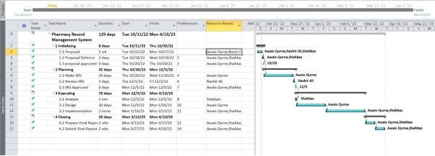

Figure 14: Gant Chart

In the figure number 14 Gant chart for Pharmacy Record Management system is presented to show the work break down structure of the Desktop app the team members and the time to complete the different activities.

**4.3 Development Tool**

**4.3.1 Introduction**

## Pharmacy Record management systems are complex pieces of software that require a variety of development tools to create and maintain. The most common development tools used for Pharmacy Record management systems include programming languages, database management systems, and software development kits. These tools allow Pharmacy to create systems that are efficient, secure, and scalable.

|  |  |  |
| --- | --- | --- |
| **Tools & Technologies** | **Version** | **Reason** |
| Windows / Windows XP | 10 or Higher | Operating System used to develop “Pharmacy Record Management System” |
| C# | 4.5 | Framework to develop “Pharmacy Record Management System” |
| .Net Farmwork | 4.5 | Programming language used by .Net framework |
| MySQL, and SQL Server | SQL 2014 | Used as database management system |
| Visual Studio 2015 | 1 (User Setup) | Used to write .Net code |
| Git | 2.38.0. windows.1 | Used to tracking change in the source code and pushing my repositories to my git-hub account |
| Adobe XD | 54.1.12 | Used to create the GUI of “Pharmacy Record Management System” |

Table : Development Tools

## 4.4 Conclusion and Future Work Extensions

In conclusion, the development of a pharmacy record management system using a desktop application provides numerous benefits such as efficient record keeping, improved inventory management, and streamlined workflow processes. The system has demonstrated its ability to enhance patient care by ensuring accurate medication dispensing and reducing errors.

Future work for this system could involve incorporating additional features such as automated prescription refills, integration with pharmacy health records (PHRs), and implementing data analytics capabilities to identify patterns and trends in medication usage. Furthermore, extending the application to a Desktop-based platform could enhance accessibility and allow for remote access to pharmacy records. These advancements would further enhance the efficiency and effectiveness of pharmacy operations while promoting patient safety and satisfaction.

# 5. QUALITY ASSURANCE

In this Chapter we can check Pharmacy Record Management System (PRMS) outlines to their processes and activities involved in ensuring the quality and reliability of the system.

## 5.1 Introduction

In quality assurance phase which is mainly based on Test plan including testing strategies and types of testing applied to ensure the reliability and accuracy of the application to give the user a great and error free product. Satisfaction of user is a first and foremost priority. The proper testing mechanism is devised and the results are tabulated in the form of test cases to trace each test case against desired functional requirement.

## 5.2 Traceability Matrix

Table of requirement traceability matrix is given below in which test cases for respective requirements are performed.

**5.2.1 User Traceability Matrix:**

|  |  |  |  |
| --- | --- | --- | --- |
| Requirement ID | Requirement Description | User Interface | Product Management |
| RQ001 | User can search for products | X | X |
| RQ002 | User can view product details | X | X |
| RQ003 | User can add products to cart | X | X |
| RQ004 | User can purchase products | X |  |
| RQ005 | User can view order history | X |  |
| RQ006 | User can login | X |  |
| RQ007 | User can register | X |  |

**5,2,2** **Admin Traceability Matrix:**

|  |  |  |  |  |
| --- | --- | --- | --- | --- |
| Requirement ID | Requirement Description | User Interface | Product Management | Admin Control |
| RQ008 | Admin can login |  |  | X |
| RQ009 | Admin can add new products |  | X | X |
| RQ010 | Admin can remove products |  | X | X |
| RQ011 | Admin can manage user accounts |  |  | X |
| RQ012 | Admin can confirm order placement |  |  | X |
| RQ013 | Admin can update shop settings |  |  | X |

## 

## 5.3 Test Plan

**Test ID: TC_01**

**Test Name: User Login**

**Date of Test: 04/02/2023**

**Application Name: Pharmacy Record Login**

**Test Description: User login with valid email and password**

**Test Case Steps:**

|  |  |
| --- | --- |
| **Test ID** | **1** |
| **Test name** | Login |
| **Date of test** | 22/05/2023 |
| **Name of website** | Pharmacy Record Management System |
| **Description** | To verify the login functionality |
| **Input** | Login with invalid username and password |
| **Expected output** | Invalid Please enter valid username and password |
| **Actual output** | Error message will disappear |
| **Test Role (Actor)** | M.Awais Qurne |
| **Test verified by** | Muhammad Shahbaz |

Table 5.1: Test case for Login

**5.3.1 Search Products**

|  |  |
| --- | --- |
| **Test ID** | **2** |
| **Test name** | Search for Medicine |
| **Date of test** | 22/05/2023 |
| **Name of website** | Pharmacy Record Management System |
| **Description** | Product Screen for selecting different products will be displayed |
| **Input** | Enter the name of product ‘Panadol’ |
| **Expected output** | All the Pharmacy products with name Panadol will be shown to the user |
| **Actual output** | Two Pharmacy product with name Panadol shown to the user |
| **Test Role (Actor)** | Muhammad Shahbaz |
| **Test verified by** | Awis Qurne |

Table 5.2: Test case for products

**5.3.2 Test Case Steps:**

|  |  |  |  |  |
| --- | --- | --- | --- | --- |
| Step | Description | Expected Result | Actual Result | Pass/Fail |
| 1 | Search for a product | Product search results are displayed | Product search results are displayed | Pass |
| 2 | Select a product from the search results | Product details page is displayed | | Product details page is displayed | Pass |
| 3 | Click on the 'Add to Cart' button | Product is added to the shopping cart | Product is added to the shopping cart | Pass |
| 4 | Verify that the product is added to the favorite product that | Shopping cart shows the added product | Shopping cart shows the added product | Pass |

**Test Role (Actor):** Muhammad Awis Qurne

**Test Verified By:** Muhammad Shahbaz

**Test Result:** Search a Product to was executed successfully, and the actual result matched the expected result. Therefore, the test case is marked as Pass.

**5.3.3 Search Medicine**

|  |  |
| --- | --- |
| **Test ID** | **2** |
| **Test name** | Search for Medicine |
| **Date of test** | 22/05/2023 |
| **Name of website** | Pharmacy Record Management System |
| **Description** | Product Screen for selecting different products will be displayed |
| **Input** | Enter the name of product ‘Panadol’ |
| **Expected output** | All the Pharmacy products with name Panadol will be shown to the user |
| **Actual output** | Two Pharmacy product with name Panadol shown to the user |
| **Test Role (Actor)** | Muhammad Shahbaz |
| **Test verified by** | Awis Qurne |

Table 5.2: Test case for medicine

**Test Result:** The search medicine test was executed successfully, and the actual result matched the expected result. Therefore, the test case is marked as Pass.

**5.3.4 Managing Profile**

|  |  |
| --- | --- |
| **Test ID** | **3** |
| **Test name** | Update the profile information |
| **Date of test** | 22/05/2023 |
| **Name of website** | Pharmacy Record Management System |
| **Description** | To verify the manage profile functionality . |
| **Input** | Enter the new username or Address or Phone Number and click update |
| **Expected output** | A message of success! updated successfully will be shown to the Screen |
| **Actual output** | Username successfully updated |
| **Test Role (Actor)** | M.Awais Qurne |
| **Test verified by** | Muhammad Shahbaz |

Table 5.3: Test case for managing profile

**Test Result:** The Update Profile l test was executed successfully, and the actual result matched the expected result. Therefore, the test case is marked as Pass.

**5.3.5 Add Cart**

|  |  |
| --- | --- |
| **Test ID** | **4** |
| **Test name** | Cart |
| **Date of test** | 22/05/2023 |
| **Name of website** | Pharmacy Record Management System |
| **Description** | To verify the cart functionality to view the detail of items added into the cart |
| **Input** | Click the specific item in the shopping cart |
| **Expected output** | All the details related to the product will be displayed |
| **Actual output** | All the details related to product will be shown |
| **Test Role (Actor)** | Muhammad Shahbaz |
| **Test verified by** | Awis Qurne |

Table 5.3: Test case for Add to Cart

**Test Result:** Add to Cart test was executed successfully, and the actual result matched the expected result. Therefore, the test case is marked as Pass.

**5.3.6 Order Product**

|  |  |
| --- | --- |
| **Test ID** | **5** |
| **Test name** | Order products |
| **Date of test** | 22/05/2023 |
| **Name of website** | Pharmacy Record Management System |
| **Description** | To verify the order functionality by placing the order. |
| **Input** | Click confer order button in cart then select payment method(Paid or unpaid), then click the CONFIRM button |
| **Expected output** | Order successfully placed |
| **Actual output** | showing that the order is placed successfully. |
| **Test Role (Actor)** | M.Awais Qurne |
| **Test verified by** | Muhammad Shahbaz |

**Test Result:** Order Products test was executed successfully, and the actual result matched the expected result. Therefore, the test case is marked as Pass.

# 6. USER MANUAL

In this chapter we can discuss about the User Manual of a Pharmacy Record Management System (PRMS) is a guide designed to help users understand and navigate the functionalities of the system. It provides step-by-step instructions and explanations in simple words to ensure users can effectively utilize the PRMS.

## 6.1 Introduction

**6.1.1 Purpose:**

The Pharmacy Record Management System is a desktop application developed in C# and SQL. It is designed to streamline and automate the management of products, orders, and companies in a pharmacy setting. This user manual provides guidance on using the system effectively to perform various tasks and functions.

**6.1.2 System Overview:**

The Pharmacy Record Management System allows the admin user to maintain a centralized database of products, manage customer orders, and handle company information. It offers features such as adding products, placing orders, generating reports, and more.

## Hardware Software Requirements for The System

**6.2.1 Software Requirements:**

* Operating System: Windows / Mac

**6.2.2 Hardware Requirements:**

* Desktop device: pc or laptop
* Internet connection: Not compulsory
* Display device: led, laptop screen, etc.

## 6.3 Installation Guide for Application

To install the Pharmacy management system on your mobile device, follow these steps:

* Open visual studio.
* Open file.
* Connect database.
* Click on start button.

## User Manual

**6.4.1 User Login**

Follow these steps to log in:

* Start App.
* Enter your User Name and password.
* Tap on the "Login" button.
* If the credentials are correct, you will be logged in to App.

**6.4.2 Adding Products to Cart**

To add a product to your shopping cart, follow these steps:

* From the order page fill the all fields.
* Specify the desired quantity.
* Tap on the "Add to cart" button.
* The product will be added to your shopping cart.

**6.4.3 Conform order:**

Follow these steps to manage your confirmation of order:

* First add to cart.
* View the list of products in your cart.
* To remove a product, tap on the "Remove" button.
* Select method (paid or unpaid).
* Tap on the "Conform order" button to proceed to the payment process.

**6.4.4 Viewing Order History**

* To view your order history, follow these steps:
* Login the system and come on dashboard
* Select the date from calendar
* Click on “search button”
* Then you will see the records

**6.4.5 Updating Profile**

To update Customer profile information, follow these steps:

* + Tap on the "Customer" option in the app menu
  + Select the customer.
  + Update your name, email address, or any other relevant information.
  + Tap on the "Update customer" button to apply the changes.

**6.4.6 Logging Out**

To log out of your account, follow these steps:

* Tap on the "Logout" option in the app menu.
* Then you come on "Login" screen.

.